

VLA Report 2018_10

PDR Review Report

Halil Temurtaş

MEHMET alp ER

NESİL BOR

FATİH YAVUZ

2018

İçindekiler Tablosu

1. Avionics and BFI 2

1.1. Avionics 2

1.1.1. Garmin G500 TXI 2

1.1.2. Garmin GTN750 7

1.1.3. Garmin GMA345 8

1.1.4. Garmin GTX345 8

1.1.5. Garmin G5 9

1.1.6. Some Usage Scenarios 10

1.2. Avionic Selection 11

1.3. Proposed Avionic Architecture 12

1.4. Garmin StarBus 14

2. Cockpit Design 15

3. Motor Interface 17

3.1. GEA 110 Engine Interface 17

3.2. EIS Components 17

3.2.1. Engine Annunciator 17

3.2.2. Carburetor Temperature Probe 18

3.2.3. Oil Temperature Probe 18

3.2.4. Fuel Flow Sensors 18

3.2.5. Brass Pressure Sensors 19

3.2.6. Stainless Steel Pressure Sensors 19

3.3. Rotax 912 Connection 20

4. Sensors 21

4.1. GPS Antenna Installation on AQUILA AT01 (A21) 21

4.2. GPS Antenna Installation on SLING 2 23

4.3. General Light Aircraft Sensors 24

5. Circuit Diagram 26

**5.1.** **Will be drawn again with sensors in professional manner.** 26

6. Crude Electrical Architecture 27

# Avionics and BFI

## Avionics

**General info about chosen avionics, will be detailed with specific details such as weight and dimension infos.**

### Garmin G500 TXI

The G500 TXi is a display and sensor system available in three display options:

* GDU 1060 – 10”display
* GDU 700P – 7”portrait display
* GDU 700L – 7”landscape display

Display options can be seen at Figure 8. Depending on system specifics one or more of the following functions may apply:

1. **Primary Flight Display (PFD)** – provides attitude, heading, air data, and navigation information to the pilot
2. **Multi-Function Display (MFD)** – provides pilot awareness of factors that may affect the overall conduct of a flight
3. **Engine Indicating System (EIS)** – provides engine and airframe operating parameters to the pilot

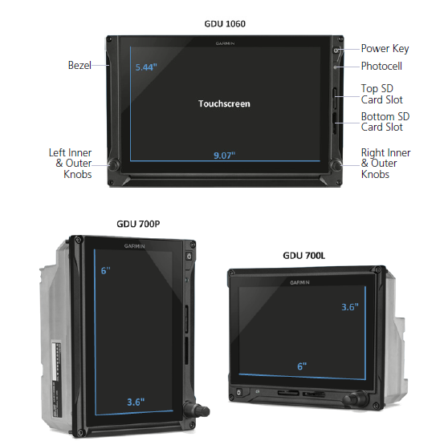

Figure 1 Display Options for G500 TXI

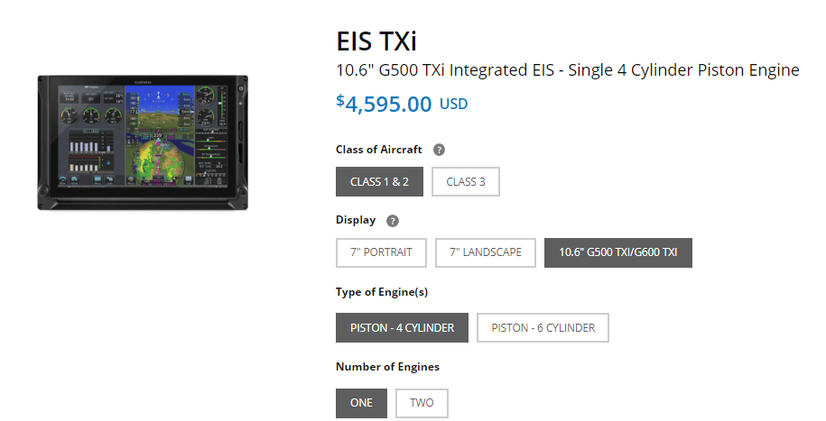

Figure 2 Garmin EIS TXI

Due to its natural support to EIS, we decided to use G500 TXI over G500. With an integrated EIS at Figure 9, G500 TXI can simply display any vital engine information at its screen. Considering the display configurations for the 1060, 700P and 700L at Figures 10, 11 and 12 respectively, we decided to use 10” configuration of the G500 TXI instead of dual 7” option. Using MFD/PFD/EIS (MFD/PFD now) configuration, pilots can be informed about the plane mostly from one device. According to cockpit group, there is enough space for additional 7” display, so we are now using 10”+7” for G 500 TXI, 7” one is EIS only.

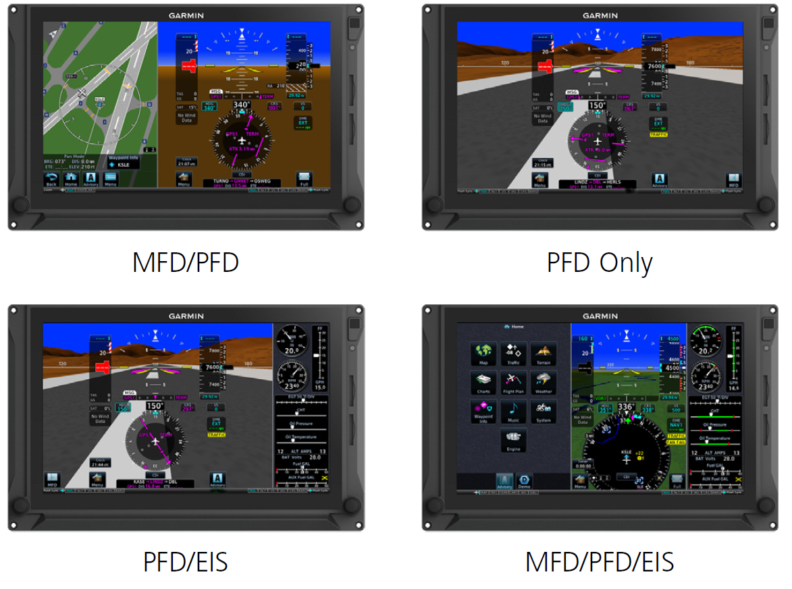

Figure 3 GDU 1060 Display Configuration

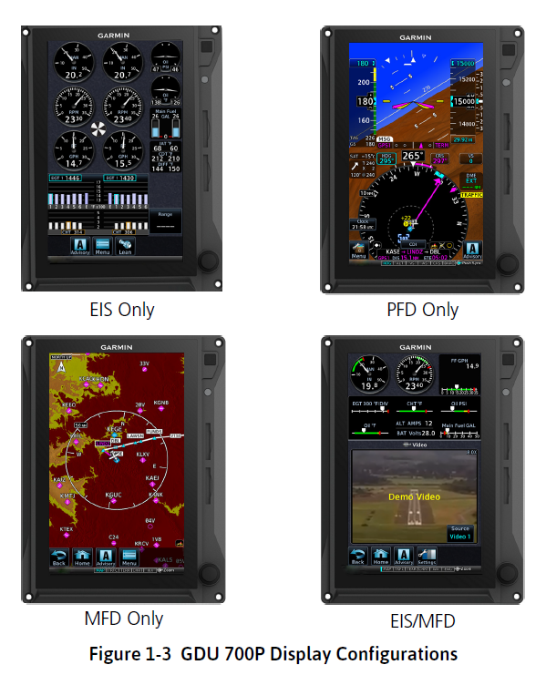

Figure 4 GDU 700P Display Configuration

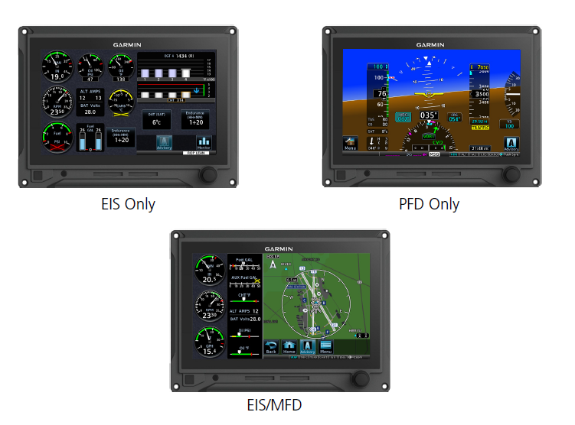

Figure 5 GDU 700L Display Configuration

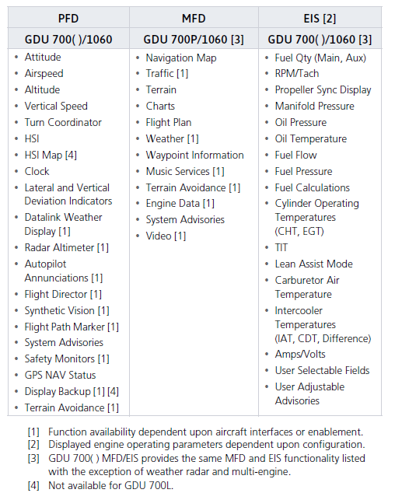

Figure 6 System Functions

System functions of G500 TXI can be seen at Figure 13 while electrical loads of subsystems of G500 TXI can be seen at Figure 14.

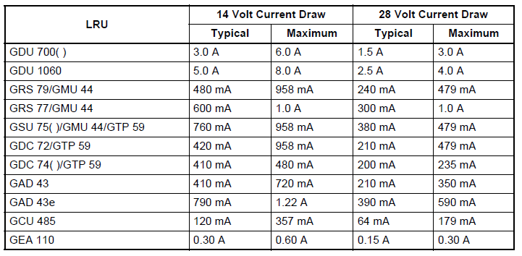

Figure 7 Electrical Load of Subsystems of G500 TXI

#### Physical Dimensions of G500 TXI

Physical Dimensions of G500 TXI can be seen at Figure 15.

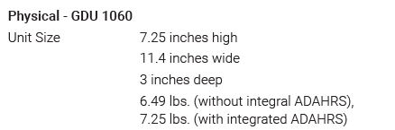

Figure 8 Physical Dimensions of G500 TXI (10”)

### Garmin GTN750

**will be detailed with specific details such as dimensions/electrical load**

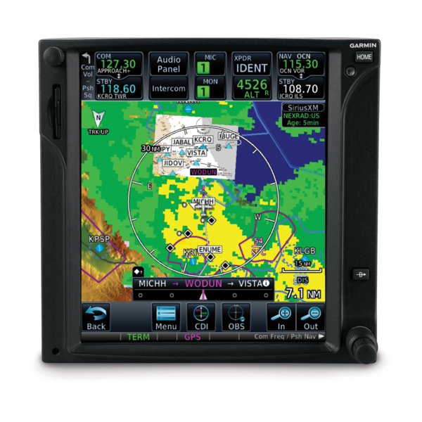

Figure 9 Garmin GTN750

### Garmin GMA345

**will be detailed with specific details such as dimensions/electrical load**

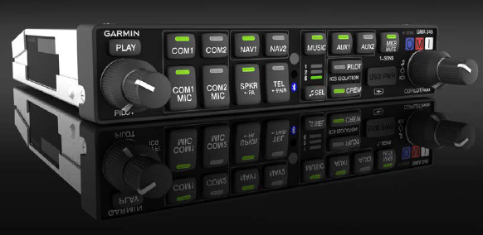

Figure 10 Garmin GMA 345

### Garmin GTX345

**will be detailed with specific details such as dimensions/electrical load**

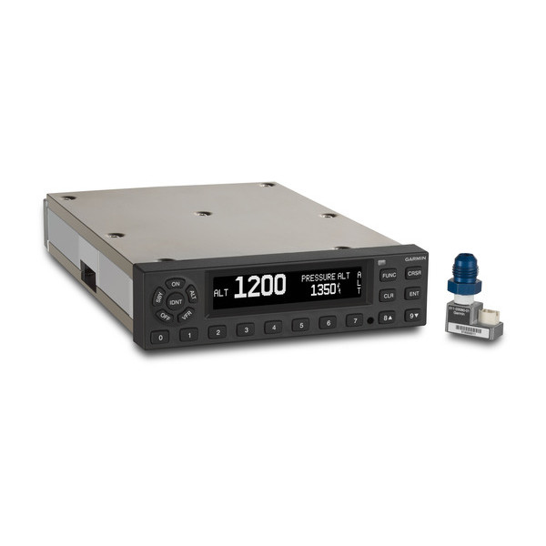

Figure 11 Garmin GTX 335/345

### Garmin G5

**will be detailed with specific details such as dimensions/electrical load**

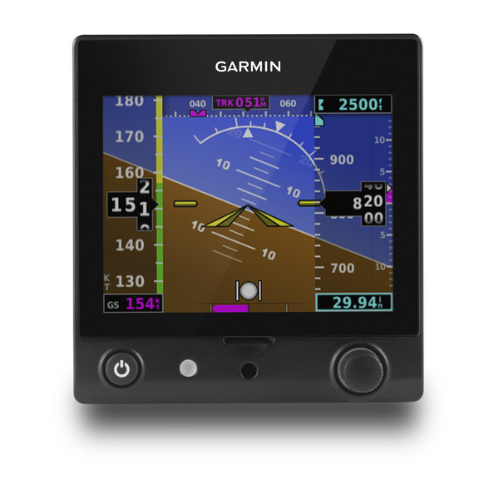

Figure 12 Garmin G5

### Some Usage Scenarios

**Can be omitted.**

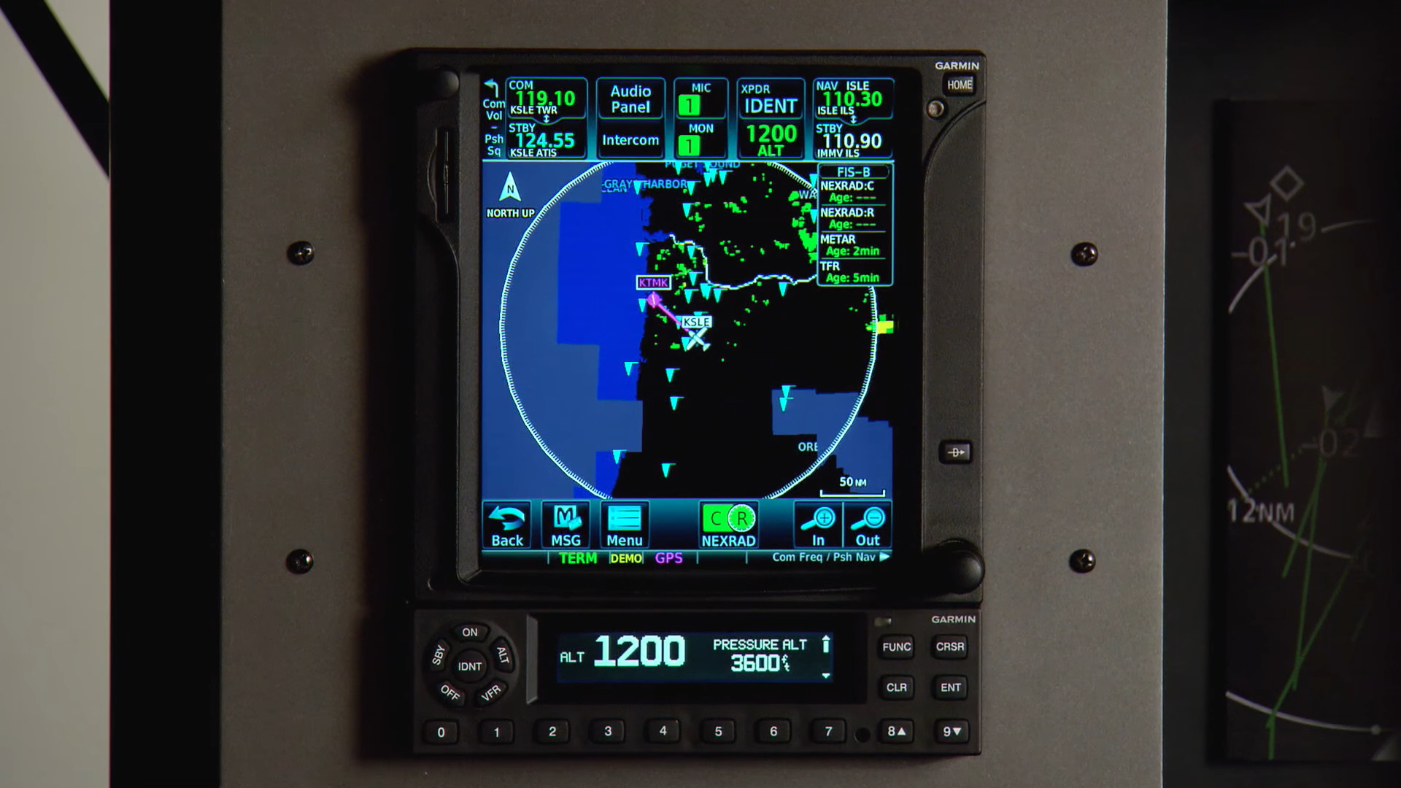

Figure 13 GTX 345 (Bottom) coupled with GTN 750 (Top)

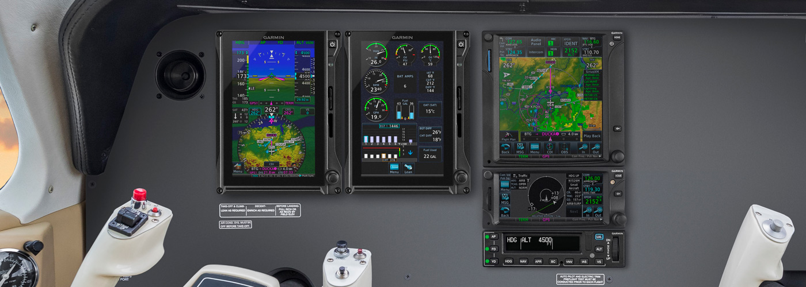

Figure 14 G500 TXI (Left) Coupled with GTN 750 (Top-Right)

## Avionic Selection

**There will be paragraph explaining tables.**

|  |  |
| --- | --- |
| **Requirement** | **Chosen Avionic** |
| ODTÜ-VLA-SRD-017 | Garmin G500-Garmin GTN 750 |
| ODTÜ-VLA-SRD-018 | Garmin G500-Garmin GTN 750 |
| ODTÜ-VLA-SRD-019 | Garmin G500-Garmin GTN 750 |
| ODTÜ-VLA-SRD-020 | Garmin G500-Garmin GTN 750 |
| ODTÜ-VLA-SRD-021 | Garmin G500-Garmin GTN 750 |
| ODTÜ-VLA-SRD-022 | Garmin GTN 750 |
| ODTÜ-VLA-SRD-023 | Garmin GTN 750-Garmin GTX 335 |
| ODTÜ-VLA-SRD-024 | Garmin GMA 340 |
| ODTÜ-VLA-SRD-026 | Garmin GTN 750 |
| ODTÜ-VLA-SRD-027 | Garmin GTN 750 |
| ODTÜ-VLA-SRD-028 | Garmin GTN 750 |
| ODTÜ-VLA-SRD-029 | Artex ME406 ELT |
| ODTÜ-VLA-SRD-030 | Garmin GTX 335 |
| ODTÜ-VLA-SRD-025 | Garmin GMA 340 |

|  |  |
| --- | --- |
| **Required Equipment** | **Chosen Avionic** |
| Seyrüsefer Ekipmanı | Garmin GTN 750 |
| Transponder | Garmin GTX 335 |
| Hız/İrtifa Göstergesi | Garmin G500 |
| Motor &Yakıt Kontrol Paneli | Garmin G500 |
| Elektrik Kontrol Paneli | Garmin G500 |
| Saat | Garmin G500 |
| ELT (Emergency Locator Transmitter) | Artex ME 406 ELT |
| Magnetic Compass | Garmin G500 |
| Statik Port | Garmin G500 |
| Pitot Tube | Garmin G500 |
| Stall Uyarısı | Garmin G500? |
| Haberleşme Sistemi | Garmin GMA 340 |

## Proposed Avionic Architecture

Figure 22 shows our design for the avionic architecture. The avionic architecture relies mainly on ARINC-429 standard, which is well known to be wide spread in non-military avionic applications. However, the system also employs discrete and Ethernet connections. To denote briefly the individual components on the architecture:

* **CV / FDR** stands for “Cockpit Voice / Flight Data Recorder”, is the black box of the aircraft.
* **G500** represents Garmin G500 dual screen electronic display.
* **BFI** or more commonly BFS is the “Backup Flight System”.
* **ADC** is the air data computer.
* **INS / GPS** stands for the Inertial Navigation System and the Global Positioning System.
* **ELT** is the Emergency Locator Transmitter.
* **ICS** is the Intercom equipment.
* **V/UHF** is the Very High and Ultra High Frequency Radio.
* **Mode-S** is the Mode-S Transponder.

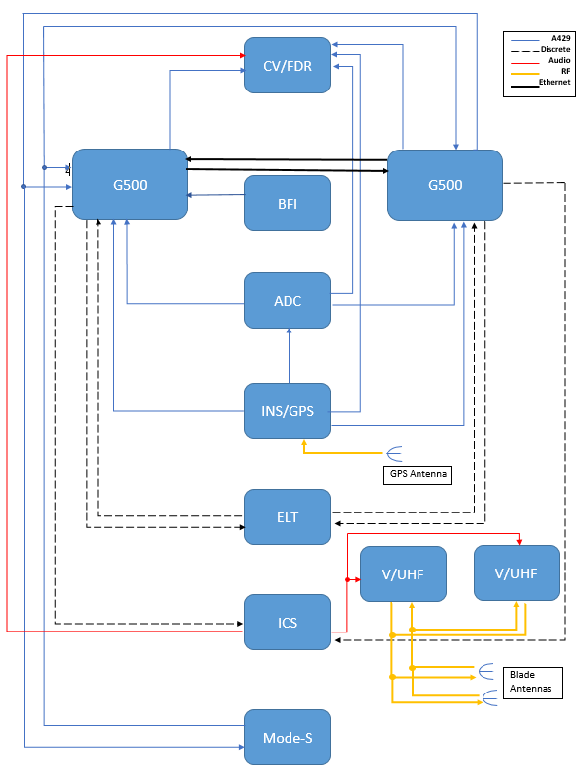

**Figure 15 : The proposed avinoic architecture. Notice the legend.**

## Garmin StarBus

**Not many information available online, research about topic continues.**

# Cockpit Design

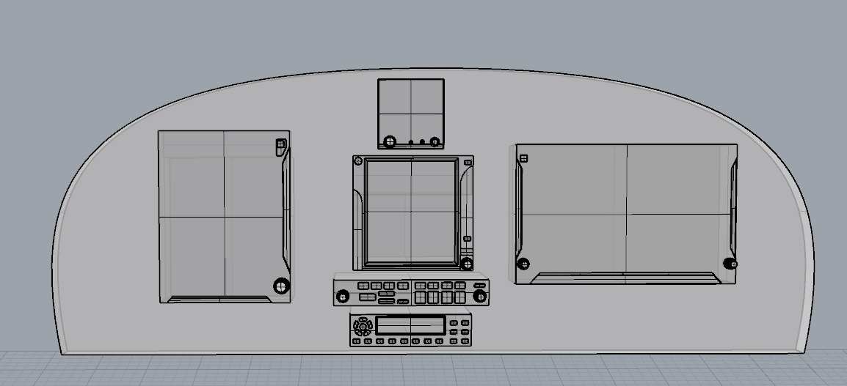

Figure 16 Proposed Cockpit Design

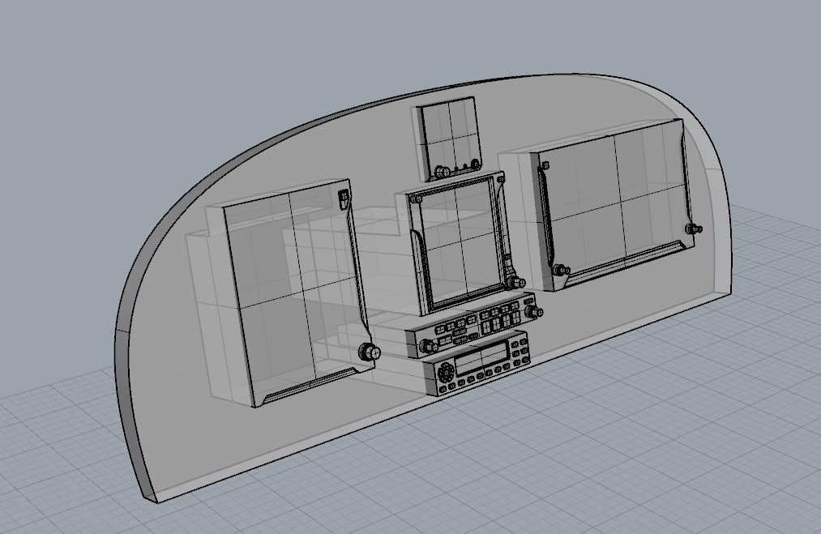

Figure 17 Proposed Cockpit Design

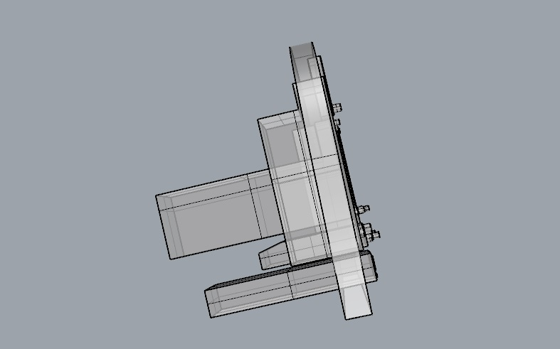

Figure 18 Proposed Cockpit Design

**Kokpit için önerilen ön tasarım. Kokpit genel hatlarıyla böyle olacak.**

# Motor Interface

## GEA 110 Engine Interface

The GEA 110 is a remote mount engine interfacing and monitoring module used for gathering sensor input parameters from the engine and processing the signals for the G500/G600 TXi system. The GEA 110 can be mounted to the back assembly of the GDU 1060 or it can be remotely mounted in the fuselage or in the engine compartment. The GEA 110 communicates with the G500/G600 TXi using an RS-485 digital interface. Device can be seen at Figure 26.

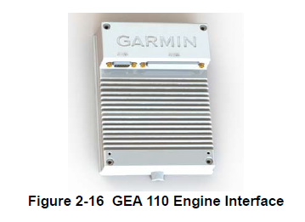

#### Figure 19 GEA 110 Engine Interface

## EIS Components

### Engine Annunciator

An engine annunciator will only be installed if the EIS display is not installed within 8 inches of the center of the pilot’s field-of-view.

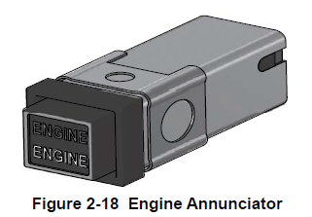

Figure 20 Engine Annunciator

### Carburetor Temperature Probe

The carburetor temperature probe is a Type-K thermocouple (Chromel and Alumel) probe.

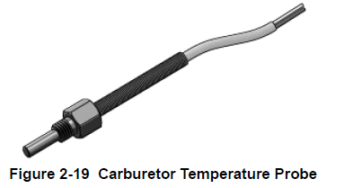

Figure 21 Carburetor Temperature Probe

### Oil Temperature Probe

The oil temperature probe is a Type-K thermocouple (Chromel and Alumel) probe.

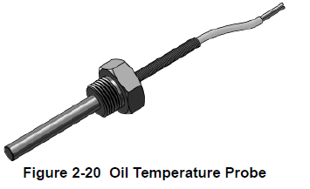

Figure 22 Oil Temperature Probe

### Fuel Flow Sensors

The fuel flow sensor is incorporated in an aluminum housing that is installed in-line to the engine fuel supply. There are two STC approved options available for installation to suit most aircraft applications.

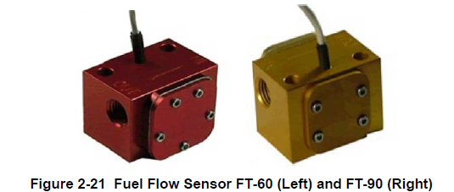

Figure 23 Fuel Flow Sensor FT-60 (Left) and FT-90 (Right)

### Brass Pressure Sensors

The brass pressure sensors are small sensors that are supplied with a compatible plug. Depending on the installation, these sensors may be used to measure oil, fuel, and manifold pressure.

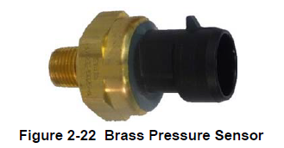

Figure 24 Brass Pressure Sensors

### Stainless Steel Pressure Sensors

The stainless pressure sensors are unamplified, high-reliability sensors for harsh installation environments. There are four sensors available to measure oil, fuel, and manifold pressure.

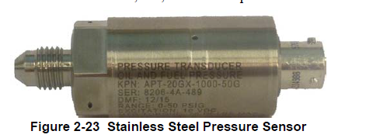

Figure 25 Stainless Steel Pressure Sensors

**P-Lead RPM Pickup**

A wire with two parallel resistors in-line connects from each P-lead, at the Magneto or the ignition switch, to the GEA 110 to sense RPM.

## Rotax 912 Connection

**Will be detailed with an information regarding exact connection between engine and EIS system.**

# Sensors

**This section will not be included in the 16.10.18 Report. But, the research about topic continues for the following report including wiring.**

## GPS Antenna Installation on AQUILA AT01 (A21)

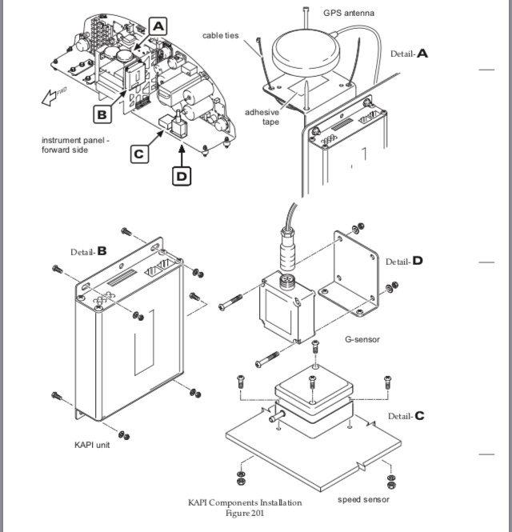

Figure 26 A

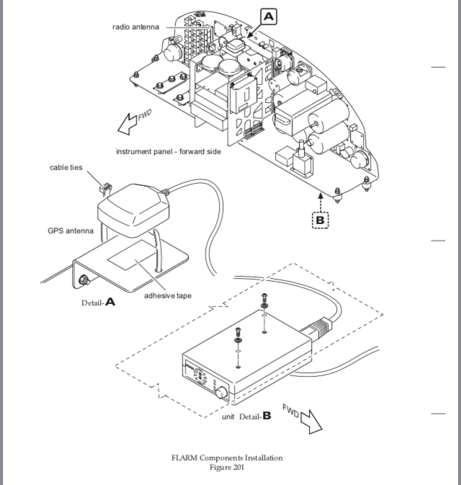

Figure 27 B

* Put gasket and antenna from outside,
* Install washers and nuts securing antenna to fuselage. Simultaneously connect ground cable to backing plate.
* Seal the antenna and gasket to fuselage using a good quality electrical sealant (Sikaflex-221 or equivalent, silicone-free).
* Connect antenna cable.
* Close baggage compartment door and install access / inspection plate 211 KC (refer to 25-12-00).

## GPS Antenna Installation on SLING 2

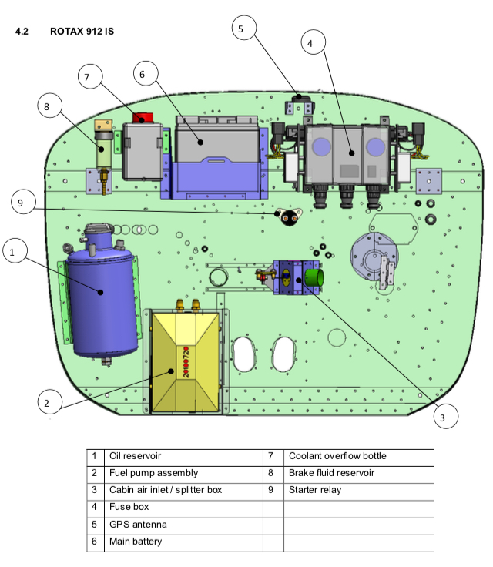

Figure 28 C

* The GPS antenna is mounted in the engine compartment on a bracket attached to the firewall.

Geçenki belgede : Alttakine benzer sekilde bir temsili ucak uzerinde yaptiginiz gosterimleri alttan kanatli ucak bulup onun uzerinde yapin. Diye bir geri bildirimde bulunmuşsunuz ama çizimleri 3 boyutlu model üstünde mi yok yine foto üzerinde mi yapmamız gerekiyor tam anlamadık.

## General Light Aircraft Sensors

On light aircraft, the comm, nav, GPS, and the transponder antennas are generally in the same locations.

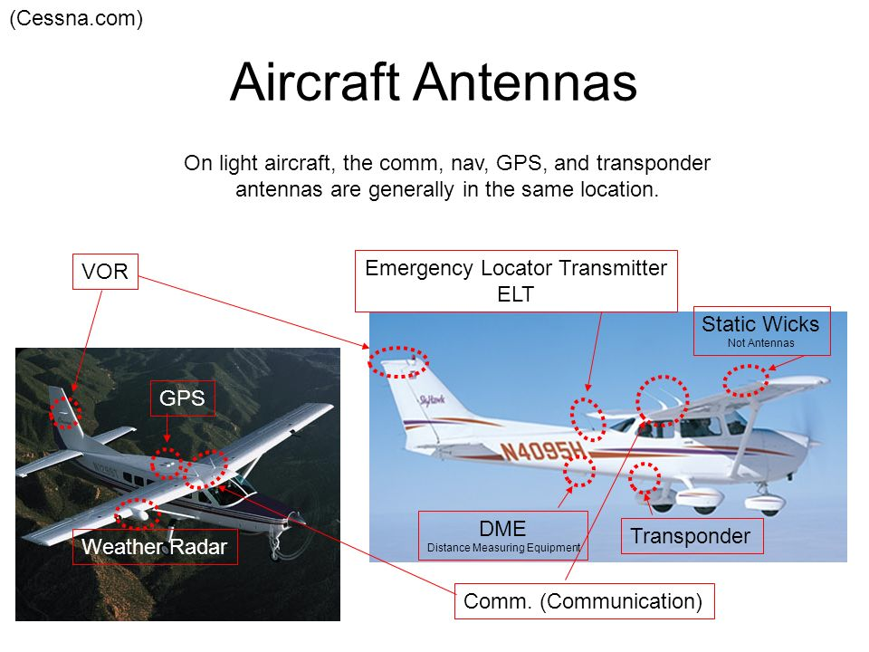

Figure 29 D

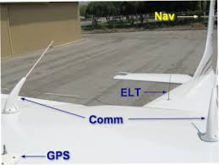

Figure 30 E

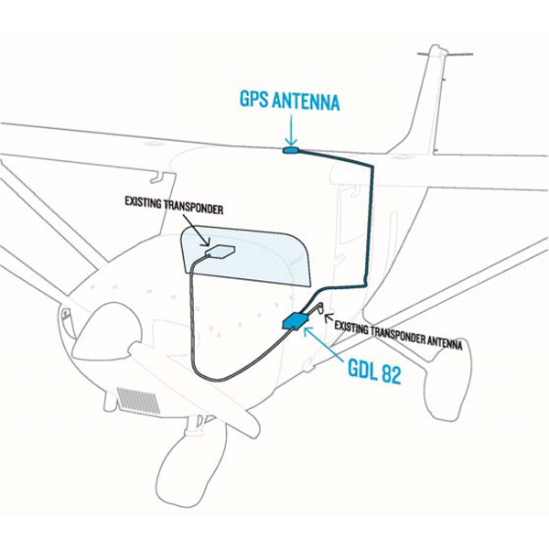

Figure 31 F

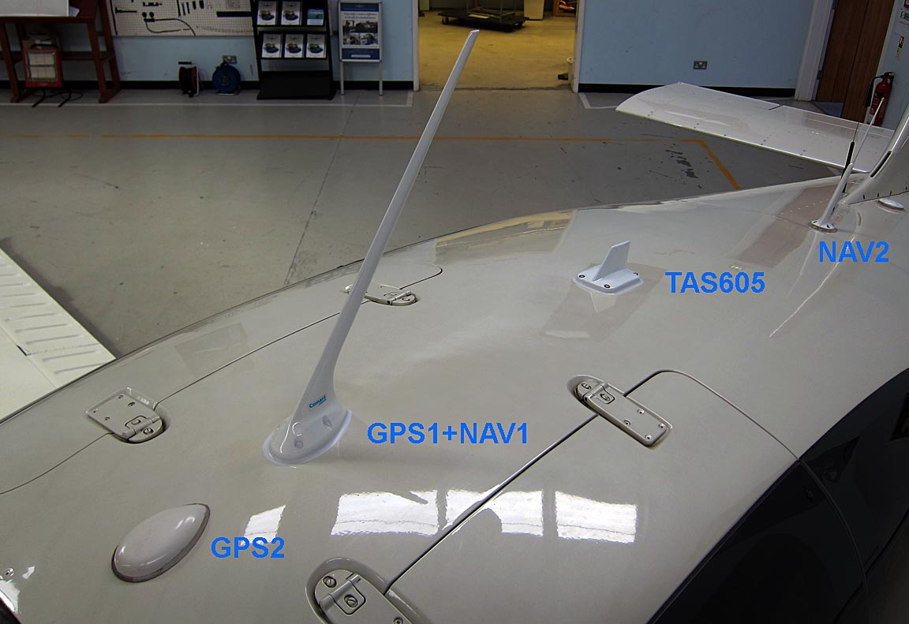

**Figure 32 G**

# Circuit Diagram

## **Will be drawn again with sensors in professional manner.**

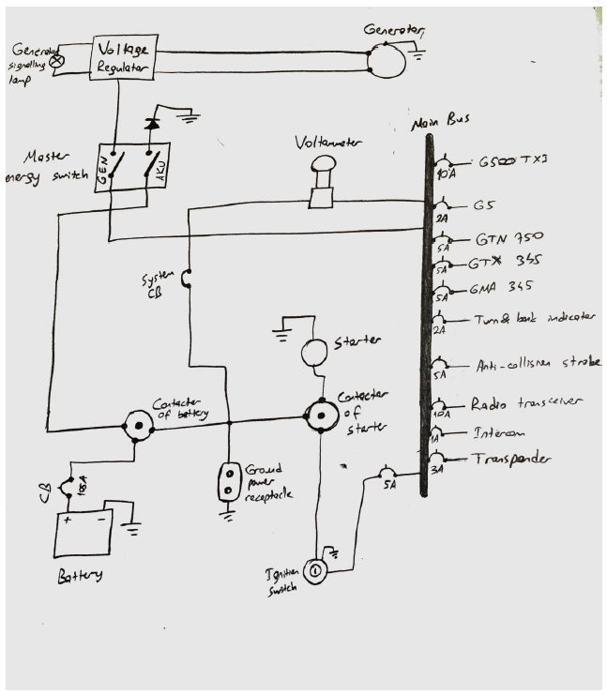

Figure 33 Circuit Diagram

# Crude Electrical Architecture

On Figure 32, you can observe the crude electrical architecture. Two busses – main and essential- are used on the architecture, typical for such aircraft. The generator relies on the engine to provide power while battery is used to provide a steady and safe source of energy in the case of a discrepancy.

* **GMFD** stands for the control panels.
* **CVR** is the black box.
* The rest is given below.

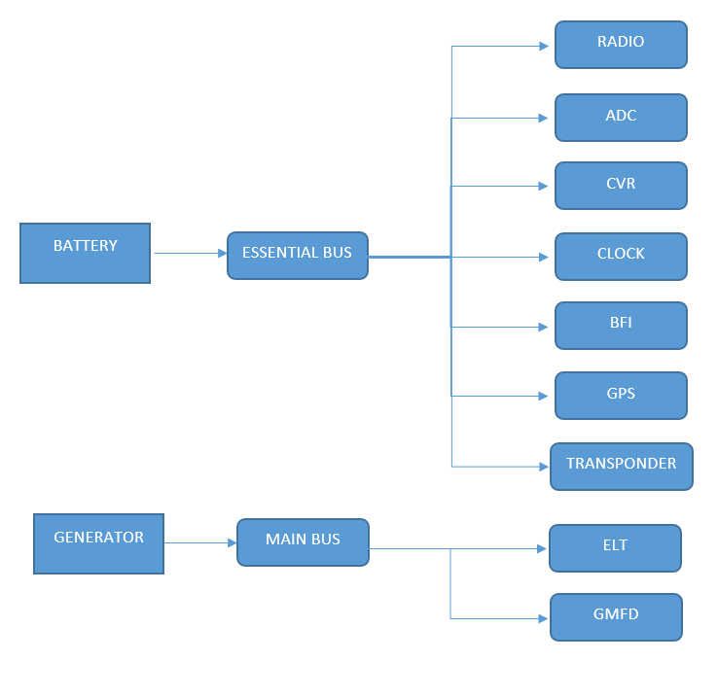

**Figure 34 : The crude electrical architecture**